Graphing Logarithms
TASK 1:
On the set of axes below, graph and label the following:

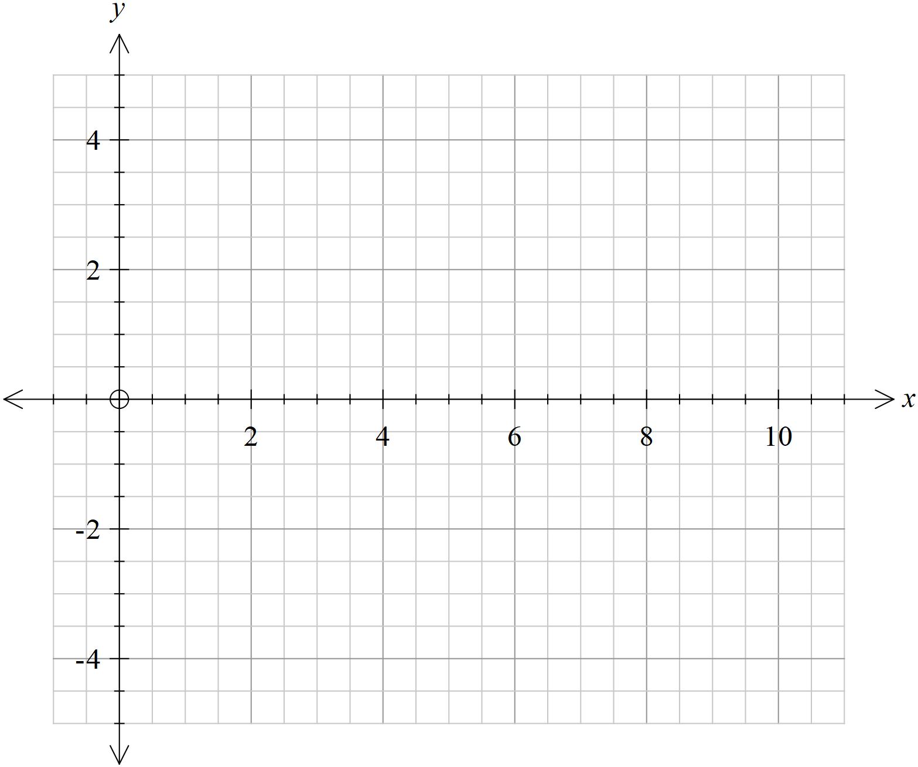

- What features do all the log graphs share?

- In what ways are they different?

- Where does each graph cross ?

- Why is this the case?

TASK 2:
On the set of axes below, graph and label the following:

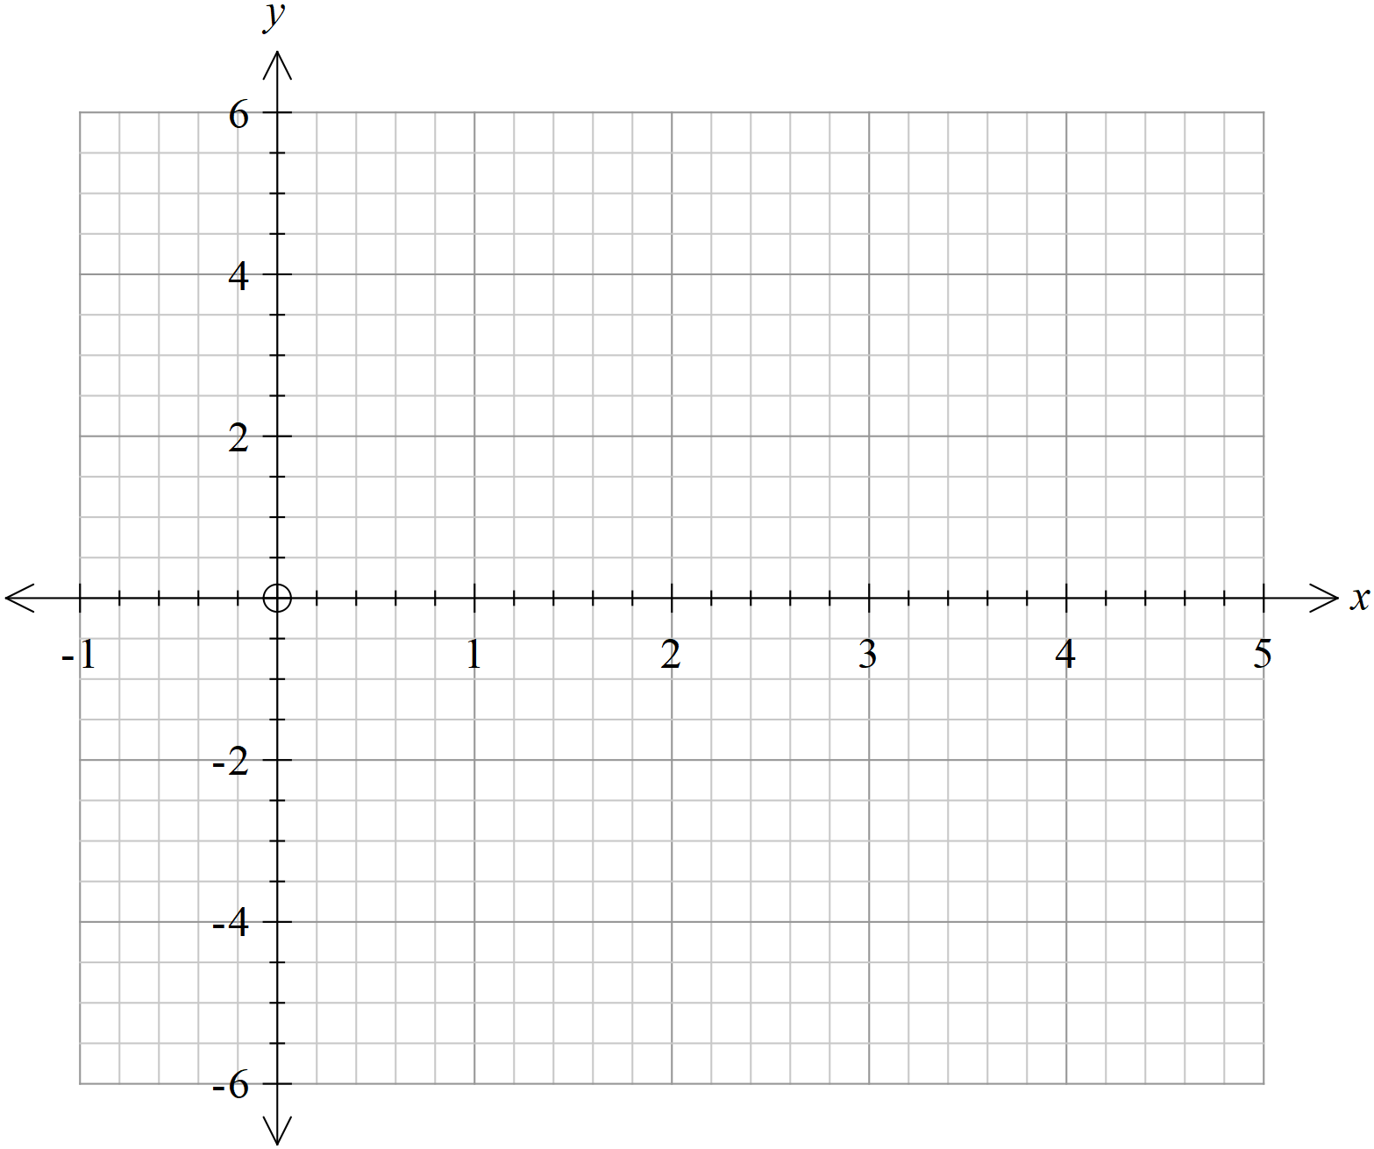

- Describe the transformation of each graph from

- Are the transformations what you expected? Why/why not?

- Let . Write each of the functions graphed above in terms of .

